Challenges and Prospects of Good Local Governance in Ethiopia: the Case of Kemisie Town, Ethiopia
By Shimelis Hailu
Department of Civic and Ethical Studies, Wollo University, Dessie, Ethiopia
Email-Address: shimellishailu@yahoo.com/kummarraatura@gmail.com
Phone No. +251924385625, P. O. Box 1145
Abstract
This paper discusses about the prevalence of good governance in some selected public institutions of Kemisie town, Amhara region, Ethiopia. To do this the researcher used pragmatic paradigm, mixed research approach. Both primary and secondary sources of data were used. To collect sound primary information interviews, FGD and questionnaires were employed. As well 206 sample populations were participated. Using five core elements of good governance the researcher reach upon the following conclusions; the general assessment of performance of good governance in Kemisie town shows that there are some progresses in establishing legal and institutional base for good governance but in terms of practices the study come across mixed results. The town achieves some progress in enhancing popular participation, government offices transparency and government accountability with some limitation. However, the government performance in terms of effectiveness and efficiency and combating corruption is not satisfactory. The practices of good governance in the town is challenged by harmful traditional practices, human trafficking, inter-house hold killing, religious fundamentalism, land related conflicts, petty corruption, partisanship and bureaucrats skills and ethical problems. Hence, the study implies that there is the need for national attention to control illegal immigration-human trafficking which is the ongoing humiliating activities in the area. Also, it needs comprehensive attitudinal change works on revenge which is the major problematic cause of killing and harmful traditional practices in the area.
Keywords: Challenges of Good Governance, Prospects of Good Governance, good governance, Good Local Governance

- Introduction
Good governance is pointed out as one of the target of Millennium Development Goals (MDG) and agenda for poverty alleviation and sustainable development. It is considered as the single most important factor in eradicating poverty and promoting development. To achieve the economic and social development, strengthening good governance is assumed to play a key role especially in mobilizing human and capital resources. In this regard Ethiopia, after long years’ tradition of centralized government and state structure, a decentralized form of government and state structure has been adopted since 1991. This can marked a dramatic change in terms of the tradition of the country’s governance. Since then, the incumbent government committed itself to eradicate poverty by introducing proven economic strategies in tandem of good governance. Among others the major successive development plan of the Ethiopian incumbent government are; Sustainable Development and Poverty Reduction Program (SDPRP), Plan for Accelerated and Sustainable Development to End Poverty (PASDEP) and successive Growth and Transformation Plan (GTP), all of which introduce good governance as one pillar which plays a key role in realizing the government’s objective of eradicating poverty by enhancing public trust and ensuring efficient allocation of public resources for development.
Despite these efforts of Ethiopian governments at both local and national levels and assistance of international community for the realization of good governance, the practice of good governance on the ground remains an area of scrutiny. Still today there are great problems of good governance in Ethiopia in general and study areas in particular. Also the assessment done to identify the current status of good governance in Ethiopia is very few; most of the source of assessment is from the government who is both the initiators and the executors of the good government agenda. The second source of literature on the topic under the study is international donors. At third level few academic journals and volume are existing. In general there is rare academic research on good governance in Ethiopia and no in the study area. Therefore, this research would be tried to fill this gap by specifically assessing the situations of good governance in Kamise town of Ethiopia. The assessment of the situations of good governance in Kamissie town would be done as planned under the successive development plan of Ethiopia against the mainstream pillars of good governance (accountability, transparency, efficiency and effectiveness, and combating corruption) Hence, this paper has the following objectives;
- To assess the current situations of good governance in Kemisie town.
- To assess the prospects of good governance in Kemisie town
- To identify the challenges of the practices of good governance in Kemisie town
- To assess the level of corruption and anti-corruption policies and practices in Kemisie town
- Materials and Methods
  - Research Approach
The approach adopted to undertake this research is mixed. Mixed approach is a research design which involves both the qualitative and quantitative approaches in a single study. As Creswell explain, all methods have limitations and felt that biases inherent in a single method could neutralize or cancel the biases of other methods (Creswell, 2006). Also, the result from one method can help to develop or inform the other method to provide insight into different levels or unit of analysis. This would enable the researcher to provide interpretive, exploratory and explanatory tools to assess the situations of good governance in Kamisie town. It also opens an opportunity for researcher to cross check data collected by one method against the others. From different strategic models of mixed approach the researcher selected explanatory sequential design; collecting and analyzing quantitative data followed by collecting and analyzing qualitative data based on quantitative data results.
  - Population, Sample and Sampling Techniques
The target population for this study is all officials (government appoints), employees (professionals or civil servants) and stakeholders receiving services in public offices in Kamisie town in State of Amhara. The number of sample sizes pragmatically decided by the researcher based on the number of employees and service receivers. Since there is no fixed number of target populations for the research, the unknown sample size determination formula (Foddy, 1988: 105) cited in (Sebsib, 2015: 87) was used:
Sample Size=$\text{PqZ}2E2$ Whereas
P= population estimated (15%)
q= refers to the value derived by subcontracting from 100: 85%
Z= refers to the level of confidence (1.96- preferred level of confidence by the researcher)
E= refers to the maximum deviation tolerated from the population (deviation from the population percentage, 5%)
=15x85x1.96²/5² ⁼4898/25 =196. Therefore, 206 respondents were identified as sample including return rate (5%). The sample size for interviews and FGD would be determined based on the analysis of quantitative data, data gathered using questionnaires. Therefore, ten officials and elders were participated in in-depth interviews while 60 individuals divided under 10 groups were also participated in Focus Group Discussion.
  - Sources and Method of Data Collection
    - Sources of Data
This study used both primary and secondary data useful to the study. Regarding literature written on the topic under study, the researcher collected information related to the topic from written documents such as books, newspapers, official reports, research findings, journal articles and government and non-government documents. As far as primary source is concerned first hand information was collected from target populations using questionnaires, interviews and Focus Group Discussions (FGD).
  - Data Presentation, Analysis and Interpretation
The quantitative data is analyzed using descriptive analysis. A descriptive method is mainly used to condense data into more informative and meaningful manner. Both Statistical Package for Social Science (SPSS version 20) and Simple statistical techniques like means, percentages and tables were used for this purpose. While qualitative data is analyzed by arranging and portraying the data collected through interviews and FGD in a way that help to detect patterns or problems, explore associations that exist in the data. In this analysis reiteration and elaborations of key concepts and suggestions would be made on the findings that fit with the existing literature under investigation. In doing so the researcher was identify dissimilarities while comparing the findings secured against literature reviews. Finally the quantitative and qualitative data integrated at data presentation stage.

- Results and Discussions

Practices of Good Governance in Oromo Nationality Zone
This subsection of the paper dealt with the practice of good governance in the study areas using the five core elements of good governance abovementioned.
    - Participation
Good governance to be prevailed, all men and women, majority and minority groups, old aged and youngsters should have a voice in decision making either directly or through legitimate intermediate institutions that represent their interests. Government alone cannot achieve good governance. For governance to be good, citizens, community based organization and civic society organizations must actively claim and affirm rights and initiate efforts to stimulate broad participation in governance process. Good governance requires local groups closest to citizens to voices pressing social, economic and political challenges and opportunities and contributes towards a shared vision for development. Good governance requires collaboration with government to create a meaningful role in public decision making. To assess the situations of citizens, civil society and community based organizations participation in the study area, ten closed ended questionnaires accompanied with the qualitative data collected from target groups using focus group discussions and interviews were presented and interpreted. Hence, the respondents were asked varieties of questions and their response to questionnaires, interviews and focus group discussions were interpreted together as follow:
Table 1: Institutional framework for the participation of society in local government decision making
 |  | Frequency | Percent | Valid Percent | Cumulative Percent
Valid | No | 88 | 48.4 | 48.4 | 48.4
Valid | Yes | 94 | 51.6 | 51.6 | 100.0
Valid | Total | 182 | 100.0 | 100.0
Source: own survey (2017)
As depicted in the table1 above out of the existing respondents 51.6% believe that there is institutional framework for societal participation in decision making of their town while 48.4% of the respondents respond that there is no any institutional framework for societal participation in local government decision making.
Although the respondents are near to equal still majority of the respondents (more than 50%-51.6%) of the respondent believe as there is institutional base for participation. To verify this debate the researcher interviewed both service users and officials and they responded that the institutional base for participation is lay down by the government but it is not applied as expected. Therefore, the officials said that those who say there is no institutional base for participation in local government decision making are those citizens who are not aware of the existing institution. Said the town civil service office head it is the weakness of local government to provide awareness on the existing system for participation. The researcher also tried to see the existing document concerning institutional framework for participation and witnessed as there are different town and sectorial based rules and regulations officially introduced to enhance the participation of stakeholders.
Table 2: Societal Perceptions on Current Level of Societal Participation
 |  | Frequency | Percent | Valid Percent | Cumulative Percent
Valid | very good | 7 | 3.8 | 3.9 | 3.9
Valid | good | 17 | 9.3 | 9.4 | 13.3
Valid | medium | 118 | 64.8 | 65.2 | 78.5
Valid | poor | 30 | 16.5 | 16.6 | 95.0
Valid | very poor | 9 | 4.9 | 5.0 | 100.0
Valid | Total | 181 | 99.5 | 100.0
Missing | System | 1 | .5
Total |  | 182 | 100.0
Source: own survey (2017)
Furthermore, respondents are asked question ‘what is the current level of societal participation in your town?’ As the above Table2 depicted majority of the respondents (64.84%) believe that the current societal participation in Kamisie town is medium while 9.3% and 3.8% of the respondents see the current societal participation in their town as good and very good respectively. It is only 16.5% and 4.9% of the respondents are perceived the societal participation in their town as poor and very poor respectively. Hence, the quantitative data show that the absolute majority of the respondents (77.94%) perceive the societal participation in decision making of local government as progressive.
In support of this the Kamisie town government communication affairs head argued that the societal participation in local government decision making increase from time to time. Further adding he said that the town government also tried its best to open all decisions for societal participation by introducing different frameworks enhancing citizens’ participation. To verify this argument the researcher tried to observe different documents as well as their workings while staying in the town for the purpose of data collection. During the time the researcher observed that the town government institutions are relatively open to serve the service seekers. Also, there are different guidelines providing a room for societal participation.
But, said the town civil service head, although the societal participation in local government decision making is increasing from time to time, there is limitation in providing inclusive participation. Specially, some husbands and fathers are still reluctant to send their wives and girls for participation. Also due to highly rampant illegal migration, youth participation in local government decision making is very low. Connecting with this the official said that illegal migration is the main challenges of good governance in the town. In the same manner the finding of Oromo nationality zone wide study conducted by Kamisie teachers teaching college shows that school dropout is high at high school level in Kamisie as oppose to other areas in the country. The finding of the college research cited illegal immigration and harmful traditional practices as causes.
Elders and stakeholders participating in interviews and focus group discussion have the same idea with the officials. Participants of focus group discussion said that the main problem of Kamisie town is illegal migration and harmful traditional practices. The elders participating in interviews have the believing that although there is government policy intervention to eradicate harmful traditional practices the society still challenged by traditional harmful practices. Some husbands are reluctant to send their wives to public forum as well some parents are still reluctant to send their girls to school than sending to Arab world or early marriage. As the account of participants’ early marriage, gender disparity and illegal migration still prevail in the town.
Table 3: Institutional Framework for the Participation of Civil society and Community Based Organizations in local government decision making
- Civil society

 |  | Frequency | Percent | Valid Percent | Cumulative Percent
Valid | no | 91 | 50.0 | 50.8 | 50.8
Valid | yes | 88 | 48.4 | 49.2 | 100.0
Valid | Total | 179 | 98.4 | 100.0
Missing | System | 3 | 1.6
Total |  | 182 | 100.0

- Community Based Organization
Valid | no | 76 | 41.8 | 42.7 | 42.7
Valid | yes | 102 | 56.0 | 57.3 | 100.0
Valid | Total | 178 | 97.8 | 100.0
Missing | System | 4 | 2.2
Total |  | 182 | 100.0
Source: Own survey (2017)
Civil society and community based organization participation is another mechanism through which good governance is enhanced in local government area. Based on this the perception of society on the participation of civil society and community based organization in local government decision making is asked. As the above table shows 50.8% of the respondents believe that there is no institutional framework for the participation of civil society in local government decision making while 49.2% of the respondents believe that there is institutional frame work for civil society participation in local government decision making. As the data shows a little bit majority of the respondents perceive the absence of institutional base for civil society engagement in local government decision making.
Somehow in different way majority of the respondents (56%) believe that there is institutional frame work for community based organization in local governance decision making while 41.8% believe that there is no institutional base for the participation of community based organization in local government decision making. The data shows that when we compare the participation of civil society and community based organization in local government decision making the society have more awareness on the participation of community based organization than civil society. To verify this issue discussion was held with both government officials and elders from the society.
Participants of the focus group discussion associated the participation of civil society with the 2009 charity and civil society proclamation. The charity and civil society proclamation prohibited foreign civil society from participating in activities linked with politics like democracy, conflict resolution, good governance and human rights under the auspices of politics is for citizens. The proclamation also prohibited domestic civil society from receiving more than ten percent funds from foreign donors. Therefore, this concern of the proclamation is cited as constraint factor for civil society participation in enhancement of local good governance.
In general, the finding of the data shows that the societal participation in Kemisie town is in progress. But the participation of women and youth is constrained by harmful traditional practices and illegal immigration respectively.
    - Effectiveness and Efficiency
Effectiveness and efficiency is one of the core elements of good governance frequently used as indicators in governance measurement. As a yardstick of good governance, effectiveness and efficiency has its own sub-indices which are changed into operational questions and included in questionnaires of this study. For the purpose of this study, ten close ended questionnaires accompanied by interviews, focus group discussions and official documents were presented in order to measure the prevalence and challenges of good governance in terms of efficiency and effectiveness in the study area.

Figure1: Levels of Customers’ satisfaction in public institutions
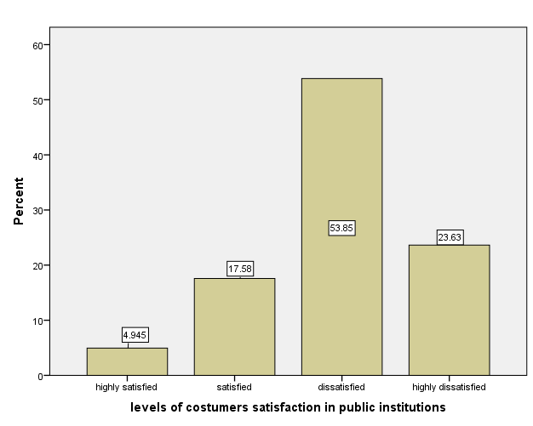
The level of customers’ satisfaction from the services of a given public institution is the major factor to indicate the status of good governance in the public institutions. Concerning kamisie town public institutions 182 peoples are participated in ranking the communities satisfaction on the public institution services. As the above bar-chart depicted majority of the respondents (53.85%) respond dissatisfaction while 23.63% respond highly dissatisfaction. Small groups 17.58% and 4.94% respond satisfaction and high satisfaction. The quantitative data shows that majority of the respondents are dissatisfied with the service provision in the town.
To enrich this date interview with officials and focus group discussion with elders was conducted and the researcher comes across the same finding. The elders participating in the focus group discussion argued that the bureaucracies in the town are too weak to provide up to time services to the society. The bureaucracy is too partisan in service provisions. In the town people get service not through the civil service laws but through informal attachments in terms of religious or friendship. In support of this the officials said that the civil servants are reluctant to provide services as expected.
Furthermore, respondents are asked to explain their opinions on the problem associated with bureaucracy in the town and majority of the respondents said ethical problem, religious based partisan and inefficiency are the main bottle neck of the well functioning of bureaucracy in the town. In support of this the town civil service office head identified petty corruption, false certificate, religious fundamentalism and partisanship as the major problems associated with bureaucracy in the town.
Table 4: The Financial Resource Management in Public Institutions
 |  | Frequency | Percent | Valid Percent | Cumulative Percent
Valid | very high | 2 | 1.1 | 1.1 | 1.1
Valid | high | 14 | 7.7 | 7.8 | 8.9
Valid | medium | 78 | 42.9 | 43.6 | 52.5
Valid | low | 58 | 31.9 | 32.4 | 84.9
Valid | very low | 27 | 14.8 | 15.1 | 100.0
Valid | Total | 179 | 98.4 | 100.0
Missing | System | 3 | 1.6
Total |  | 182 | 100.0
Source: own survey (2017)
The other yardstick of measuring efficiency and effectiveness of public institution is financial resource managements. Concerning this 1.1%, 7.7%, 42.9%, 31.9% and 14.8% of the respondents responded very high, high, medium, low and very low respectively. Although the response is sparsely distributed majority of the respondents (42.9%) responded medium followed by those respond low (31.9). the result is controversial to judge. To verify this researcher interviews officials and held focus group discussion with elders.

The officials participating in interviews said that there are some progresses in opening financial use transparency but still the financial resources use of the town is in problem. Further adding said the officials’ petty corruption like favoritism, nepotism and abuse of power is the main problem of the town. The civil service office head also said that the petty corruption in the town is very high citing as the town is on the process of investigating and come across many problems of petty corruption. Furthermore, the respondents who respond poor and very poor financial resource management were again asked additional question of explaining the major reasons for the poor performance. Among others the respondents identified three major factors as reasons for poor financial management: corruption, inefficiency and absence of concern.
Table 5: public institutions vulnerability to political pressures

 |  | Frequency | Percent | Valid Percent | Cumulative Percent
Valid | very high | 28 | 15.4 | 16.5 | 16.5
Valid | high | 26 | 14.3 | 15.3 | 31.8
Valid | medium | 72 | 39.6 | 42.4 | 74.1
Valid | low | 32 | 17.6 | 18.8 | 92.9
Valid | very low | 12 | 6.6 | 7.1 | 100.0
Valid | Total | 170 | 93.4 | 100.0
Missing | System | 12 | 6.6
Total |  | 182 | 100.0
Source: own survey (2017)
The major controversial issue in public service is the relationship between politics and bureaucrats. Some scholars argued that bureaucracy should be subordinate to politics with technical autonomy while others argued that bureaucracy should be autonomous in all aspects. This debate is theoretically ongoing. But the aim of this paper is not debating over theories of bureaucracy rather it aimed at evaluating the Ethiopian performance in line to existing practices. As the above table depicted majority of the respondents (39.6%) believe that the political pressure on bureaucracy is medium while 14.3% and 15.4% of the respondents said that the political pressure on bureaucracy is high and very high respectively. On the other hand 17.6% and 6.6% of the respondents responded by saying that the political pressure on bureaucracy is low and very low respectively. The cumulative result shows that there is political influence on bureaucracy during public service provisions.
The participants of focus group discussion forward the ideas which support the finding of quantitative data. The discussant said that there is no any activity performed in the town without getting green light from the politicians by citing as the town Amhara National Democratic Movement polity bureau is more powerful than the town administration. Adding the participants said that all civil servants prefer to go to the party bureau than the town administration since the party decision is final over all government decisions. In general the research finding shows that the kamisie town public institutions have low performance in effectiveness and efficiency. As the data shows the main factors for this are petty corruption like favoritism and nepotism, partisanship, false certificate, political pressure and religious fundamentalism.
    - Accountability and Transparency
Institutions good governance has also been assessed based on accountability and transparency. Also in FDRE constitution accountability and transparency are among the pillars of the constitution (FDRE constitution, 1995: Art.12). Although, accountability and transparency are the two big pillars/yardsticks of good governance, for the reason of comprehensive understanding and since the behaviors of the two elements is intertwined, the researcher explains together in this sub-section. In this respect to measure the prevalence of government accountability and transparency six close ended questionnaires followed by qualitative data collected through interviews, FGD and official documents were presented and interpreted as follow;

Figure 1: Clarity of Rules and Regulations in Local Government
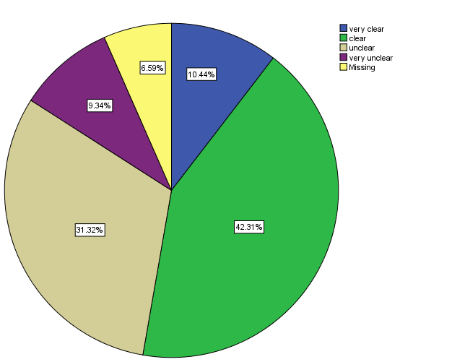
Source: Own survey (2017)
As the above pie-chart shows 10.44%, 42.31%, 31.32% and 9.34% of the respondents respond very clear, clear, unclear and very unclear respectively. As seen above majority of the respondents (42.31%) depicted that the rules and regulations in the town is clear while followed by respondents who believe that the rules and regulations in the town is unclear. As seen from the quantitative data although majority of the respondents said the rules and regulations of the town is clear still significant numbers of the respondents have the perception that the rules and regulations of the town is unclear. To clarify this ambiguity the researcher held interviews and focus group discussion with government officials and elders respectively.
The officials said that their town is more open to the people than any local government in the region by showing different guidelines clearly showing their plans, rules and regulations of the town to the interviewer. The researcher also witnesses the existence of clear rules and regulations in different government sectors. Further said the officials there is the need to create awareness and working according to the rules and regulations citing these as the two factors leading some respondents to respond as the rules and regulations of the town is unclear. Participants of focus group discussion also reach upon the same argument. They said that the town currently begins to clarify its rules and regulations but this do not changed into action as well as many of our people do not know it.
Table 6: Disclosure of Procurement Procedures in Public Institutions
 |  | Frequency | Percent | Valid Percent | Cumulative Percent
Valid | No | 106 | 58.2 | 61.3 | 61.3
Valid | Yes | 67 | 36.8 | 38.7 | 100.0
Valid | Total | 173 | 95.1 | 100.0
Missing | System | 9 | 4.9
Total |  | 182 | 100.0
Source: own survey (2017)
While talking about government institutions transparency procedures of disclosing procurement is the major concern. In kamisie town the situation is crucial issue as the same elsewhere. As the above table shows majority of the respondents (58.2%) responded as they have doubt on the transparency of procurement procurers in their town while 36.8% of the respondents respond that the procurement procedures in their town is transparent.
The result shows that majority of the participants believe as the procurement procedure is not disclosed for the society in a clear manner. In support of this the officials participating in interviews said that the procurement process in their town lack transparency. The officials further argued that the main source of rent seeking and petty corruption is the procurement procedures by citing some examples of currently investigated corruption case in the town. Participants of focus group discussion also argued that procurement is the area where the public properly is stolen.

Figure 2: Public Institutions Transparency toward the Community
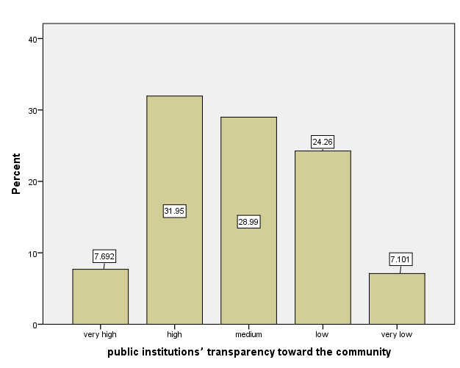
Transparency may be defined as public access to knowledge of the policies and strategies of government. It is the free flow of information which can be enhanced through the improvement of democratic process. Transparency toward the community is one pillars of good governance. based on this when we tried to see the situations of transparency in kamisie town, 7.69%, 31.95%, 28.99% and 7.1% of the respondents said very high, high, medium, low and very low respectively. As the data shows majority of the respondents (31.95%) said that the levels of public institutions transparency toward the community is high followed by those who responds the level of transparency as medium (28.99%). The cumulative result showed that the participants believe that the government office transparency toward the society is at good stage.

The researcher also observed some different behavior from the office in the town in terms of opening the door of their office and welcoming for service receivers. The finding of this study is similar with the same study conducted in the country in different local government. For example, study conducted by Kassahun Yirga in Debra Birhan town has relatively similar findings. The finding of Debra Birhan town public institution transparency toward community is 36.6% of the respondents answer good whereas 9.7% of the respondents answer very good. With some differences the finding of both study tend to the conclusion that the respective institution under study are transparent to the community in their day to day activities. But the small numbers of very poor and poor answers point as there are concerns on transparency. Therefore, in this study it is possible to conclude that the perception of kamisie town society toward government transparency is good but there are some indicators of problem of government transparency.
Figure6: Accountability of Officials and Workers in Public Institutions
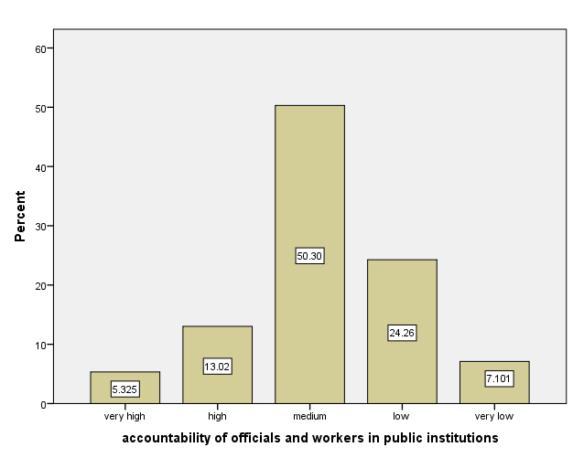
Accountability is defined as the process by which actors provide reasons for their actions under the pain of sanctions. It may be administrative, financial, legal and political accountability. It can also divide as vertical and horizontal accountability. Vertical accountability is public officials answer to the general public and they are voted out of office for violating their duties. Horizontal accountability on the other hand refers to the capability of state institutions to check abuses by other public agencies and branches of government. In this study focus is given to vertical accountability.
Pursuant to this scenario respondents are asked, to rate the level of government accountability in their town. As depicted above 5.3%, 13.02%, 50.3%, 24.26% and 7.1% of the respondents respond very high, high, medium, low and very low respectively. The data shows that majority of the respondents (50.3%) believe that government accountability in their town is medium followed by those respondents who perceive government accountability in their town is low.
The participants of focus group discussion have different views from the majority of the respondents of questionnaires. The discussant argued that there is no accountability of government officials by pointing to political appointees. The discussant said that there are problem of good governance in the town like illegal immigration, petty corruption and land related problems but the officials associated with these all problems of good governance are not accountable. If the people request the government to question a given officials said the discussant the only measure taken up on he/she is changing the individuals from one woreda to another woreda or promoting to regional and federal level by naming some individuals who pass through this track.
The town civil service office head also forward ideas strengthening the views of focus group discussion participants. The official said that the major problem of good governance in the town is human trafficking, killing, land related problem, petty corruption and harmful traditional practices. But said the head, the officials associated with these problems especially officials who participate in corruption have leverage by giving example of some corrupt officials imprisoned but released after one month. Also he said that the police forces who are reluctant to effectively perform their function to control illegal migration and killing are not taking a responsibility till today. Adding the officials said that all people know the facilitators of illegal migration (the combination of illegal agent, police, security and court) but no one is take a responsibility.
    - Combating Corruption
Combating corruption is one of the pillars of good governance. Although, some donor institutions do not explicitly including combating corruption as a pillar of good governance other inter-governmental organizations like African Union and African Development Bank (ADB) give great emphasis for combating corruption as yardstick of good governance. The researcher also took combating corruption as independent measurement as well as assessment of situations of corruption as one specific objectives because of the Ethiopian good governance package took corruption as the major challenging factor of good governance and combating corruption as major measurement of Ethiopian good governance packages. Due to this combating corruption dealt with separately in this sub-section. For the purpose of this sub-section three close ended questionnaires, in-depth interviews, FGD and official documents were presented and interpreted as follow:
Table 8: Monitoring and Reviewing Procedures to follow up the Implementations of Anti-corruption Policy
 |  | Frequency | Percent | Valid Percent | Cumulative Percent
Valid | No | 98 | 53.8 | 59.0 | 59.0
Valid | Yes | 67 | 36.8 | 40.4 | 99.4
Valid | 3.00 | 1 | .5 | .6 | 100.0
Valid | Total | 166 | 91.2 | 100.0
Missing | System | 16 | 8.8
Total |  | 182 | 100.0
Source: own survey (2017)
The focus of Ethiopia concerning good governance is reducing corruption through expanding anti-corruption policy and implementations. According to successive development plan of Ethiopia one way of enhancing the effectiveness of this goal is through developing the active participation of society in monitoring and reviewing the implementation of anti-corruption policy. Concerning this respondents are asked to reflect the practices of anti-corruption policy in their town and majority of the respondents (53.8%) answered as there is no framework for society to monitor and review the implementation of anti-corruption policy while 36.8% of the respondents argued that the town has procedural frameworks through which the society monitor and reviews the implementation of anti-corruption policy. The researcher also tried to verify this finding by interviewing officials and reviewing some documents related to the issues. The officials explain that there are different anti-corruption packages and different rules and regulations established from federal to local government in order to enhance the participation of community in monitoring and reviewing anti-corruption policies of the country. But the main problem is corruption is sophisticated practices which the community is not easily follows up and monitors it. The researcher also comes across different anti-corruption, good governance, human rights and democracy performance manuals and packages. Participants of focus group discussion also said that we hear about corruption only on meetings but in practices it seems that the officials by themselves have no heartfelt interest to halt corruption.
Figure 3: Severity of Corruption in the kemisie town 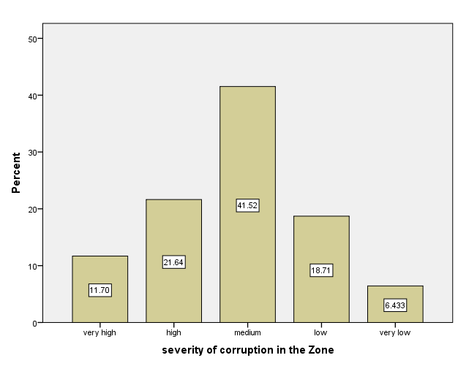
As discussed in the above sub-sections one pillars of achieving good governance is reducing corruption. Corruption is the anti-thesis of democracy and good governance. Hence, this question aimed at measuring the progress achieved in reducing corruption in the study area. As the above bar-chart shows majority of the respondents believe that the current severity of corruption in the study area is medium which 21.64% and 11.7% of the respondents argued it is at high and very high level. On the other hand 18.7% and 6.4% of the respondents believe as it is reduced rating the status as low and very low respectively.
The cumulative result shows that the severity of corruption is rampant in the study area. In support of this view the officials participating in interviews said that although there is no clear grand corruption in the town, petty corruption is rampant and is one of the main challenges of good governance in kemisie town. Adding the participants of focus group discussion explain that corruption like favoritism, nepotism and abuse of power are the day to day activities in the town.

Combating Corruption

Participation

Effectiveness and Efficiency

Good Governance
Some improvements in opening government office for servants but still procurement procedures are vulnerable to corruption

Transparency

Accountability

some improvements in accountability but still political appointees are not answerable for their actions and decisions
Legal and institutional base for societal, CSO and CBO participation but has limitation on women and youth participation due to the challenges of HTP and illegal migration respectively

Weak performances, Service provision in the town is vulnerable to informal attachment, petty corruption and inefficient bureaucracy
Problem of petty corruption like favoritism, nepotism and abuse of power

- Conclusions and Recommendations
The overall practices of good governance in kamisie town shows that the legal and institutional framework is laid down whereas the practice is still at various stages. As the result of the study shows, institutions assessed have not been found perfectly effective or totally fail in any of the five good governance yardsticks used in this study. Instead they were found effective in some of the sub-indices of the yardsticks and ineffective in some other sub-indices of the used yardsticks. For example, concerning popular participation, the town record progress in introducing rules and regulations and some institutional frameworks for individual, civil society and community based organizations participation in government activities. But, in practice the participation of all society is not achieved as expected. Specially, women participation is not as expected. In the town some husbands and fathers are still unwilling to send their wives and children to community participation. Also the data shows that some government officials are reluctant to openly receive the participation of people from different sectors of the society. Youth participation is also low due to the humiliation of illegal migration.
Concerning effectiveness and efficiency of government works the research finding come across weak performances. As the finding shows the societies satisfaction in the town government service is low. Also there is a political influence on bureaucrats in the town which according to the finding hinders some efficient bureaucrats to perform their activity freely. As well, the finding of the study shows that the procurement procedure of the town is vulnerable to corruption. The town financial management skill is medium but still challenged by corruption, inefficiencies, carelessness of the workers and ethical problems of bureaucrats. Overall the town does not achieve progressive performance in terms of effectiveness and efficiency.
The third yardstick used to measure kemisie town good governance performance is transparency. As far as performance of transparency in the town is concerned the town achieves progressive performance. Relative to other areas the working environment of the kemisie town is openly receive the service seekers of the town. As the finding shows they record progress in improving government offices openness to the society. The forth indicators of performance of good governance used to measure the performance of good local government in Kemisie town is accountability. As the finding shows the level of accountability of government officials is medium. Meaning that there are some progresses in increasing official accountability in the town but still some officials are not really accounted for the actions and decisions they take when we see political appointees. As the research participants’ views political appointees are not accountable for the actions and decisions they took, the only measure taken against them is changing from one area to the other area or promoting to regional and federal level.
The fifth and last yardstick is combating corruption and concerning this indicator the Kemisie town records weak performances. As the finding shows there is no improvement in combating corruption in the town rather petty corruption like favoritism, nepotism and abuse of power become public. To conclude the town achieves some progress in introducing legal and institutional framework conducive for the practice of good governance but the practice is challenged by harmful traditional practices, human trafficking, killing, religious fundamentalism, land related conflicts, petty corruption and bureaucrats skills and ethical problems. Hence, the study implies that there is the need for national attention to control illegal immigration-human trafficking which is the ongoing humiliating activities in the area. Also, it needs comprehensive attitudinal change works on revenge which is the major problematic cause of killing and harmful traditional practices which limit women’s participation.

- Reference
African Development Bank and African Development Fund, (1999), Bank group policy on good governance.
Creswell, John.W, (2006), Qualitative, Quantitative and Mixed Methods Approach, Second Edition, Saga Publication.
FDRE Ministry of Finance and Economic Development,(2007), the Plan for Accelerated and sustained Development to End Poverty (PASDEP).
______(2010), Growth and Transformation Plan, 2010/11-2014/15, Volume I: Main Text.
Meheret, Ayenew, (2014), “The growth and transformation plan: opportunities, challenges and lessons, (eds) in Dessalegn Rahmato, Meheret Ayenew, Asnake Kefale and Birgit Haberman, (2014), Reflections on Development in Ethiopia: New trends, sustainability and challenges, Forum for Social Studies (FSS) and Friedrich Ebert Stiftung.
Sebsib, Hadis, (2015), Women in the Informal Sector: Retrospect’s and Socioeconomic Responses in Dessie town, Ethiopia: The case of Parallel Trading, International Journal of Developing Society, Vol. 4, No.2, Pp 85-94.

